The Material World
Chapter 1
Characteristic physical properties: Density: formula p=m/V; g/cm³=g÷cm³ or g/mL=g÷mL, or density (p) is equal to mass (m) $÷$ by volume (V) 1 cm³ = 1 mL
Properties of solutions: Solutions: solute is dissolved in a solvent.
Ex: salt = solute dissolved in water = solvent, solution = salt water.
Concentration: amount of solute dissolved in solution. C=m/V g/L=g÷L, %(m/V), %(m/m), %V/V, g/L
x ex¹: 25L x 1000 = 25,000mL
1L = 1000 mL
÷ ex²: 372mL ÷ 1000 = 0.373 L
X10
X10
X10
X10
X10
X10
King Henry Died Uncle Didn’t Care Much
÷10
÷10
÷10
÷10
÷10
÷10
Kilo Hecta Deca (m,l,g) Deci Centi Milli

Organization
Pure substance: ¹⁾ Element: contains 1 type atom/particle. N, Nitrogen , OR N₂
²⁾ Compound: at least 2 different atoms: Nitric Oxide , glucose C₆H₁₂O₆
³⁾ Molecule: at least 2 atoms: Nitric Oxide , or Nitrogen
Mixtures: ¹⁾ Homogeneous: uniform throughout (looks the same): solutions ex: salt water, steel, air
²⁾ Heterogeneous: can see the different parts: granite, sand and water, smog
Chapter 2
Radiant
Chemical
Mechanical
Thermal
Forms of Energy: T he M an R aces C ars
Objects in motion
Electromagnetic wave

R M I V U X G
Chemical bonds
Random movement of particles

Other forms: electrical, wind, sound
Transformation of Energy: Energy changes form; starts as one turns into another.
Ex: chemical (wood) Radiant (light)
Thermal
Chapter 3
Fluids: flows and takes shape of container.
FLUIDS
types
COMPRESSIBLE INCOMPRESSIBLE
Can change its volume Can’t change its volume
GASES LIQUIDS
O₂, CO₂ Blood, Urine, Sweat
Chapter 4:
Waves
Frequency: # of cycles (wavelengths) / unit of time (s) in Hz.
Frequency = pitch

Wavelength (ʎ):
wavelength
wa
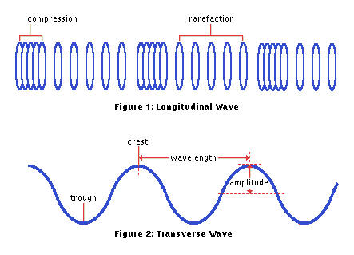

Longitudinal: shorter the wavelength = more energy
Longer the wavelength = less energy

Transverse: shorter the wavelength = more energy
Longer the wavelength = less energy

Amplitude: transverse wave: distance from equilibrium to crest or trough. Higher = more energy
longitudinal wave: region of compression. Smaller = more energy
- Indicates volume: greater amplitude, the higher the volume

Deviation of light waves:
¹Reflection: bouncing of light rays off a surface.
Specular reflection: angle of incidence = angle of reflection creates mirror image.
Diffuse reflection: angle of incidence ≠ angle of reflection see objects.
²Refraction: deviation of light rays passing through different transparent medium.
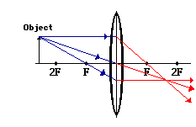
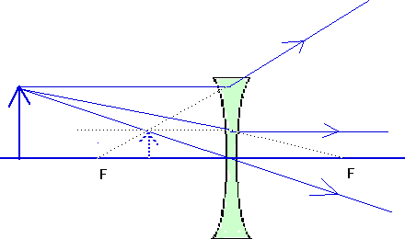
Use lenses to refract light: converging lens and diverging lens

Chapter 5
Cell division: ¹mitosis and ²meiosis
¹Mitosis: produces 2 genetically identical cells with 46 chromosomes = diploid.
-for growth and repair of tissue Ex: for someone still growing (cell count), fix broken bone.
²Meiosis: produces 4 genetically different cells with 23 chromosomes = haploid. (only 1 cell for females)
-for formation of sex cells/gametes

Sexual Development:
Pituitary Gland
Releases
FSH and LH

Primary
Primary
Secondary
* Hair (body, underarms, pubic)
* Body odour, acne
* Psychological changes

Females
Matures ovaries
Stimulates production and secretion of Estrogen and Progesterone
Males
Matures testes
Stimulates Testosterone production

Produces
Sex Cells
(Gametes)
Spermatozoa/
Sperm
Ova/Eggs

Chapter 8

Vaccinations: stimulates an immune response creating immunity.
- Triggers production of antibodies
- Stimulates quick antibody production when re-exposed.
3 Types: ¹ Live (attenuated): use whole virus to make. Ex: MMR, polio
² Inactive: use part, the antigens to make. Ex: typhoid, cholera, flu
³ Genetically engineered: whole virus with modified DNA. Ex. Hep B, HPV
Combination Vaccines: multiple in one shot.
Booster: extra dose after a few years to reintroduce infectious agent for immunity.

Assisted reproduction: facilitate union between sperm and egg.
4 types: ¹Ovarian Stimulation: hormones injected into female to cause ovarian follicles to mature. Used if
you rarely ovulate.
- To increase chance of fertility
²Artificial Insemination: Semen injected into uterus. Used if low sperm count or motility.
³ In Vitro Fertilization: ovum with sperm fertilization in petri dish (in lab), embryos implanted into uterus.
⁴Microinjection: sperm nucleus injected into egg.

CHAPTER 6
Nutrition: Can Frank/Larry Please Visit My Walmart
Types of foods
Digestive system
Digestive tract: My Parents Eat Salami Sandwiches Like Red Apes
Transformation of food: mechanical and chemical digestion
Respiratory and circulatory systems
Respiratory system: Naughty Nick Planted Lettuce & Tomatoes Behind Lazy Betty’s Apt.
Circulatory system
Functions of
blood constituents:¹Plasma: waste (urea, CO₂), nutrients, hormones, antibodies
²formed elements (Red =moving O₂, White=phagocytosis, Platelets= blood coagulation)
Lymphatic system:
Role: ¹Filters lymph: spleen and lymph nodes
²Fighting Infection: white blood cells (lymphocytes) produce antibodies; battle in lymph nodes; body remembers to produce antibodies: neutralize and mark for death. WBC eat (phagocytosis) infectious agent.
³Returns fluid to blood: lymph is dumped into subclavian veins.
Lymph = plasma = Extracellular fluid
Excretory system: eliminate wastes
Urinary system: KUBU
Components of urine: Urea, water, minerals, medication, drugs,

CHAPTER 7
Nervous and musculoskeletal systems
SIGHT
Sensory receptors: stimulus-sensory organ-converter-transporter-processor
Eye: CAPIL V BROCS
Musculoskeletal system
Function of joints: Connection between 2 or more bones. Allows for movement.
Types of joint movement Fixed, Semi-movable, Freely movable (examples for each)

The Technological World
Chapter 11
Graphical Language
Basic lines: study 338-339
Scales: Scale reduction: when drawing is smaller than object. Ex: 1:40 Note: measurement always in mm.
Scale Increase: drawing is larger than object. Ex: 40:1
Full Size: drawing is the same size as object. Ex: 1:1
Dimensioning: what the range measurement needs to be to still work. Ex: 5+ 0.7 5+0.7 = 5.7, 5-0.7 = 4.3
Tolerances range: 4.3-5.7
Chapter 12
Mechanical Engineering
Basic Mechanical Functions: Linking (connects), Guiding (controls movement), Sealing (air tight, block off), Lubricating (reduces friction)
motion transmission systems: always same motion (rotational) Fred Smiles Politely Causing Winks

motion transformation systems: change of motion (r-t or t-r) Some Rats Can Skate

Electrical engineering (pg. 401)
Power supply: battery, electrical outlet
Conduction: wires, circuit board
Insulation: wire sheath, anything that doesn’t conduct electricity
Protection: fuse, circuit breaker
Control: power switch
Transformation of energy: light bulb (radiant), blender (mechanical), radio (sound)

Materials
Mechanical properties of materials: Hardness (doesn’t indent), Elasticity (returns to shape), Ductility (can stretch and keep shape= wire), tensile strength (resist tension), Malleability (can flatten or bend), Resilience (resist shock)
Other properties: Corrosion Resistance (won’t rust), electrical conductivity, thermal conductivity, density
Constraints: Torsion (twisting), Compression (towards each other), Tension (opposite forces)

