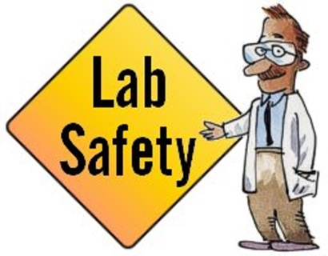
SCIENCE LAB SAFETY RULES

Experimenting in the science lab is safe if you are careful! Each student must assume responsibility for the safety of themselves and those around them. The following safety rules should help guide you in keeping our lab a safe place to work.

1. The science lab is used for serious work only. No horseplay will be permitted.
2. Do not perform unauthorized experiments. Always obtain your teacher’s permission before doing any experiments.
3. Study your lab experiment carefully. If you are in doubt about any procedure, ask your teacher.
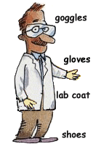
4. Use the safety equipment provided for you, know their location and proper use.
5. Safety glasses must be worn when substances are being heated or when mixing or pouring chemicals.
6. Report all accidents, injuries or incorrect procedures to your teacher at once.
7. If clothing should catch fire, smother it with a blanket/coat or use emergency shower. NEVER RUN!!
8. If you spill a chemical substance, ask for proper cleaning procedure.
9. Never taste any chemical or transfer chemicals by mouth pipette.
10. Never eat or drink in the lab. 11. Never inhale chemicals.
12. Keep combustible materials away from open flames. 13. Do not throw paper or solids into the sink.
14. If glass is broken, call your teacher for help and dispose in glass trash-bin.
15. Equipment replacement and/or repair costs due to carelessness will be charged to the student responsible for the damage.
16. If unsure how to use a piece of lab equipment ask for instruction and/or demonstration prior to using equipment.
17.___________________________________________ 18.________________________________________________
19._________________________________________ 20.________________________________________________
21._________________________________________ 22.________________________________________________
Laboratory First Aid
1. Report all accidents, injuries, or incorrect procedures at once.
2. In case of bleeding contact your teacher immediately.
3. If any substance is spilled on you or gets into your eyes, wash with plenty of water and notify your teacher.
4. Minor burns should be immersed in cold water at once. For severe burns, notify your teacher immediately.
5. In case of fainting or collapse, give the person fresh air and recline him so that the head is lower than the body.
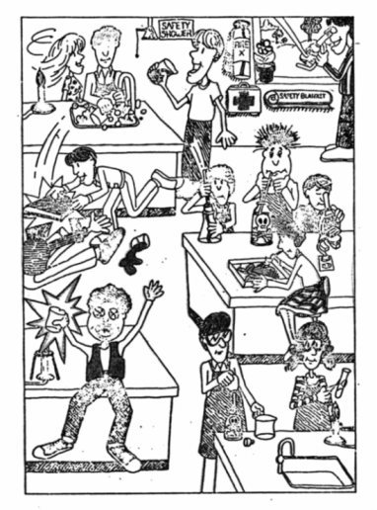
Laboratory Nightmare

APPLIED SCIENCE AND TECHNOLOGY
LAB SAFETY, RULES AND REGULATIONS, WORK STANDARDS

To Parents and Students,
We are excited to be starting the 2016-2017 school year. We want to ensure that all students have a successful year. The course outline, safety lab procedures and this letter are reminders of the expectations for grade 9 science. We make every effort to develop safe activities for students and to instill a sense of responsibility for safety in all of our students. As such ED (Electronic Device) Corner has been set up in the classroom. If students have made the choice to bring their ED to class then, upon entering the class, students are to place their ED or devices in their designated spot. All other safety guidelines and expectations have been discussed in class.
Students have been provided a copy of all chapter notes. However, in the event that students lose their notes they will be posted on my teacher website: http://msezekiel.weebly.com. Students will be required to print a new copy. Also, all major test and assignment dates will be posted. Students are expected to get every test and quiz signed as part of the ongoing communication between home and school. Students will be receiving their own textbook, toolbox and workbook at the beginning of the school year. They are responsible for ensuring that their texts and workbooks are present at every class. Lost workbooks and textbooks must be replaced at the student’s own expense. It is the student’s responsibility to catch up on any missed lab work, assignments, and tests when they have been absent from school. All missed tests and labs are to be completed on the subsequent Wednesday afternoons. Students who fail to attend a Wednesday afternoon will receive a zero. We are looking forward to another fun and safe year in science.
Students should discuss these expectations with parent(s)/guardian(s) and return the detachable portion to school with student and parent signatures. This will demonstrate that students understand the rules and expectations and have communicated those expectations with their parents.

Sincerely,

Ms. Ezekiel
9th grade Science Teacher

----------------------------------------------------------------------------------------------------------------------------------------

I ____________________________ have reviewed the course outline, classroom expectations, lab safety procedures and work standards for grade 9 science with my parent/guardian and I agree to follow the guidelines so that I may be successful during my 2016-2017 school year.
(Student Name)

Student Signature _____________________ Parent Signature ______________________Group #:________

