Name:__________________________________ Group:_____ Date:________________________

**Chapter 3 Fluids**

1. **Fill in the table below.**

|  |  |  |
| --- | --- | --- |
| **Type of Fluid** (Scientific terms) |  |  |
| **Type of Fluid** (Everyday term) |  |  |
| **Examples found in the body** |  |  |
| **Examples found outside the body** |  |  |
| **Draw a visual representation of each.** |  |  |

**Chapter 4 Waves**

1. Name the 2 ways waves propagate. ___________________________ ________________________________
2. Name the 6 categories of electromagnetic waves and give an example of each.

|  |  |
| --- | --- |
| Electromagnetic Wave | Example |
|  |  |
|  |  |
|  |  |
|  |  |
|  |  |
|  |  |

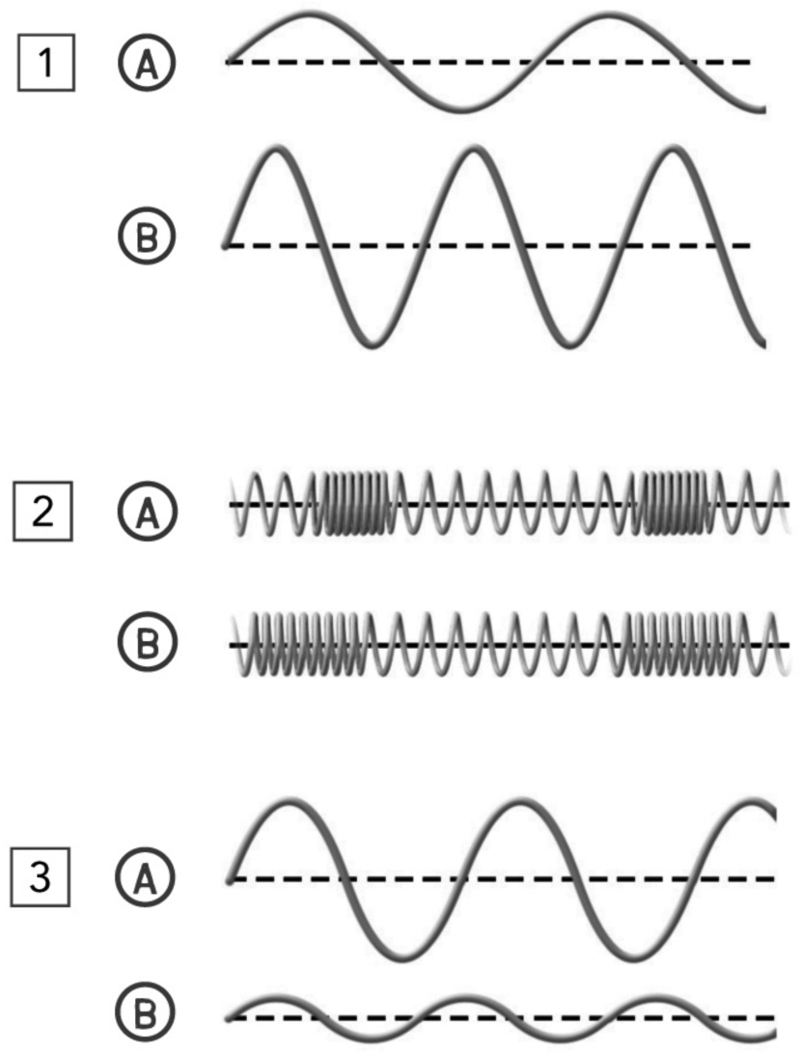

1. *1)* For each pair of waves indicate the following:

Most energy: 1______ 2______ 3_______

Greatest Amplitude: 1______ 2______ 3_______

Highest Wavelength: 1______ 2______ 3_______

Assuming the time lapsed is the same:

Lowest frequency: 1______ 2______ 3_______

*2)* Looking at the waves in both pairs 1 and 2, which wave is transporting the

most energy? Explain. _____________________________________________

________________________________________________________________

*3)* a) Which waves for each pair are the loudest?

1______ 2______ 3_______

b) Justify your answer:___________________________________________

______________________________________________________________

______________________________________________________________

______________________________________________________________

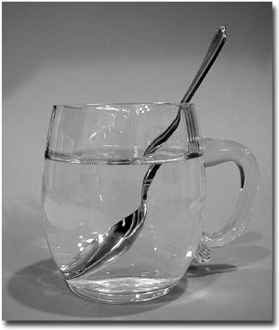

Explain why the spoon looks “broken”.

________________________________________________________________________________________________________________________________________________________________________________________________________________________________________________________________________________________________________________________________________________________________________________________________________________________________________________________________________

_________________________________________________________________

1. Name the 2 phenomena of light and briefly explain each

1) ________________________ : ________________________________________________________

2) ________________________ : ________________________________________________________

1. A) Name the 2 types of reflections: 1________________________ 2__________________________

B) Give an example of each: 1_________________________________________________________________

2_________________________________________________________________

1. Name the 2 types of lenses and what they do to light.

_______________________ -___________________________________________________________________

_______________________-____________________________________________________________________

9. Indicate what is happening to light in each of the images below and briefly explain each.



_____________________

___________________



_______________

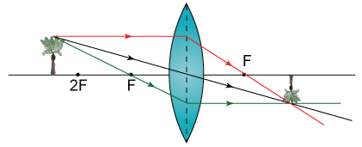

____________________

Explain:__________________________ Explain:_______________________________________

______________________________ ____________________________________________ Explain:______________

______________________________ ____________________________________________ ___________________

______________________________ ___________________

______________________________ ___________________

___________________

**Chapter 5 Reproduction**

10. Fill in the following table about the 2 types of cell division.

|  |  |  |  |
| --- | --- | --- | --- |
| Type of cell division | Function | Number of daughter cells | Genetically identical or different? |
|  |  |  |  |
|  |  |  |  |

11.

a) What is the purpose of mitosis in a female?__________________________________________________

b) What is the purpose of meiosis in a female?____________________________________________________

c) What is the purpose of mitosis in a male?______________________________________________________

d) What is the purpose of mitosis in a male?______________________________________________________

e) Where does mitosis occur in a female?________________________________________________________

f) Where does meiosis occur in a female?________________________________________________________

g) Where does mitosis occur in a male?__________________________________________________________

h) Where does meiosis occur in a male?_________________________________________________________

12.

|  |  |  |  |  |
| --- | --- | --- | --- | --- |
| **a)** How many chromosomes does a human diploid cell contain? | |  |  |  |
| **b)** How many chromosomes does a human haploid cell contain? | |  |  |  |
| **c)** What kind of cells is formed during meiosis? |  | |  |  |

1. Fill in the following table regarding hormones.

|  |  |  |
| --- | --- | --- |
| **Hormone** | **Secreted by** | **Role(s) during puberty (general)** |
| FSH |  |  |
| LH |  |  |
| Estrogen |  |  |
| Progesterone |  |  |
| Testosterone |  |  |

1. Fill in the following table regarding male and female sexual characteristics.

|  |  |  |
| --- | --- | --- |
|  | Male | Female |
| Primary sexual characteristics |  |  |
| Secondary sexual characteristics (3) |  |  |

15. Janice lives on an isolated rocky corner of the world raising goats. She’s decided to venture into the big city but her friends warn her that she should get vaccinated before traveling among huge groups of people.

1. What is the purpose of a vaccine?

____________________________________________________________________________________________________________________________________________________________________________________________________

1. What are the benefits to being vaccinated?

____________________________________________________________________________________________________________________________________________________________________________________________________

1. What are the types of vaccines and briefly describe each?

______________________________________________________________________________________________________________________________________________________________________________________________________________________________________________________________________________________________________

16. Indicate the assisted reproduction treatment being utilized in each scenario described below.

a) A specialist deposits the spermatozoa in the woman’s uterus._______________________________________

b) In the laboratory, a specialist puts an ovum in contact with several thousand spermatozoa.______________________

c) A specialist implants embryos in the woman’s uterus.______________________________________

d) This treatment is used to correct ovulation problems, or it is used in conjunction with artificial insemination or in vitro fertilization._________________________________

e) Fertilization takes place in the laboratory.______________________________________________________________

f) In the laboratory, a spermatozoon is inserted directly into an ovum.________________________________

**Extra Extra Questions.**

17. Indicate if the following is an example of a heterogeneous or homogeneous mixture, element or compound, pure substance.

|  |  |  |
| --- | --- | --- |
| Material | Pure Substance or Mixture | Element, Compound, Homogeneous |
| concrete |  |  |
| sugar + pure water (C12H22O11 + H2O) |  |  |
| iron filings (Fe) |  |  |
| limestone (CaCO3) |  |  |
| air inside a balloon |  |  |
| aluminum (Al) |  |  |
| tap water |  |  |
| pure water (H2O) |  |  |

18. Identify the following as compound, molecule or both.

a) CaCl2 _________ b) NO2 _______ c) F2 _________ d) H2SO4 ____________ e) O2 ___________

The human body is made up of an abundance of substances. Fill in the table according to the statement in the first column.

|  |  |
| --- | --- |
| Name 3 solutions. | 1. 2. 3. |
| Give 2 examples of energy transformation. | 1. 2. |
| Give 2 examples of pure substances. | 1. 2. |