**Name:_________________________________ Group #:_____ Date:__________________**

**Chapter 6**

1. This is what Veronica ate for supper:

|  |
| --- |
| – 1 grilled Atlantic salmon steak  – 1 baked potato  – 5 mL of butter (on the potato)  – 3 boiled broccoli florets  – 2 glasses (500 mL) of 2% milk  – 125 mL of chocolate ice cream  – 60 g of strawberries (on the ice cream) |

**For each food item eaten by Veronica:**

a) Name the main nutrient that would be provided.

b) Indicate where it’s broken down in the

digestive system.

c) Indicate what the nutrient breaks down into.

d) Indicate main nutrient function

e) Indicate where it’s being absorbed.

|  |  |  |  |  |  |
| --- | --- | --- | --- | --- | --- |
|  | a)Main Nutrient | b)chemical  breakdown location | c)Nutrient  breakdown | d) Function(s) | e)Absorption location |
| Salmon | |  |  |  |  |  |
| Potato | |  |  |  |  |  |
| Butter | |  |  |  |  |  |
| Broccoli | |  |  |  |  |  |
| Milk | |  |  |  |  |  |
| Ice cream | |  |  |  |  |  |
| Strawberries | |  |  |  |  |  |

2. What is the mnemonic to help you remember the 6 nutrients and their functions?

______________________________________________________________________________

3. Draw a labelled diagram of the urinary system.

4. A) Label the structured parts of the digestive system.

B) Indicate with a M (mechanical) or a C (chemical) where these types of digestion take place.

C) Briefly indicate the purpose of each structure.

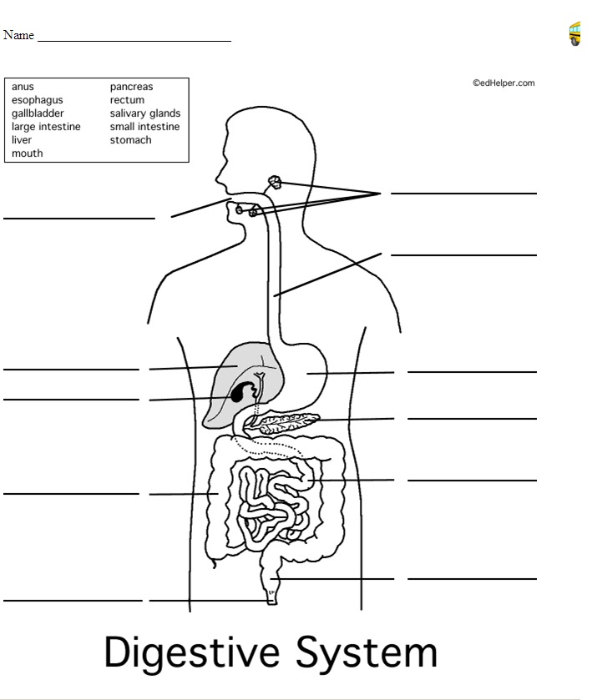

______________________________________________________________________________

_______________________________________________________________________________________________

_____________________________________________________________

________________________________________________________________

_____________________________________________________________________________________________________

____________________________________________________________________________

________________________________________________________

_____________________________________________________

_____________________________________________________________________________________________________________________________

_____________________________________________________________________________________________________________________________

_____________________________________________________________________________________

__________________________________________________

5.What is the mnemonic to help you remember the parts of the digestive tract?

____________________________________________________________________________

6. What is the mnemonic to help you remember the different digestive glands?

____________________________________________________________________________

7. Each of the following statements describes one of the body’s vital functions. In each case, name the system that manages this function.

|  |  |
| --- | --- |
| **a)** Consume food to extract nutrients to keep our bodies healthy. |  |
| **b)** Nutrients carried by blood provide energy for our cells. |  |
| **c)** Clean blood, we eliminate certain waste products like urea. |  |
| **d)** Our sense of smell allows us to distinguish various odours. |  |
| **e)** Monitors our CO2 levels and processes stimuli from our environment. |  |
| **f)** Allows us to maintain body temperature at 37 degrees Celsius and allows  for both voluntary and involuntary movement. |  |

8. What type of mobility do joints allow? Give an example of each.

|  |  |
| --- | --- |
| Joint | Example |
|  |  |
|  |  |
|  |  |

9. Our respiratory system enables us to extract a fluid from the air, which we need in order to live.

|  |  |
| --- | --- |
| a) Name this fluid. |  |

b) What type of fluid is this?

|  |
| --- |
|  |

c) What type of fluid travels the reverse path of the one mentioned in b?____________________

____________________________________________________________________________________________________________

10. Outline the path air takes from Inhalation to Blood; begin with *nose* and end with *blood*.

Inhalation (Indicate when it’s only O2)

__________________-_____________________-___________________-_________________-

__________________-_____________________-___________________-_________________-

__________________-_____________________

11. Look at the diagram of the respiratory system below. Fill out the table provided.

|  |  |
| --- | --- |
| http://www2.sluh.org/bioweb/bi100/focussheets/fscirculation_respiration_lungs.pngName | Function |
| 1. |  |
| 2. |  |
| 3. |  |
| 4. |  |
| 5. |  |
| 6. |  |
| 7. |  |
| 8. |  |
| 9. |  |

12. Name 10 blood constituents and briefly indicate their purpose.

|  |  |
| --- | --- |
| Blood constituent | Purpose |
| 1. |  |
| 2. |  |
| 3. |  |
| 4. |  |
| 5. |  |
| 6. |  |
| 7. |  |
| 8. |  |
| 9. |  |
| 10. |  |

13. There are a lot of different substances that can be found in human blood.

1. Name the formed elements of blood and give their respective functions.

|  |  |  |  |
| --- | --- | --- | --- |
|  | Element |  | Function |
| 1 |  |  |  |
| 2 |  |  |  |
| 3 |  |  |  |

1. Where are they made?________________________________________________
2. What system makes the formed elements?_________________________________

14. While observing lymph through a microscope, you see a white blood cell wrapped around a microorganism.

a) What is happening?________________________________

b) Where would this most likely be taking place in the body?____________________________

c) What system would this most likely be occurring in?_________________________________

d) How did the white blood cell know to attack the invader?_________________________________________

e) What will happen if the same type of invader comes back into this body? Full explanation.

____________________________________________________________________________________________________________________________________________________________________________________

15. a) What systems are part of the excretory system? ______________________________________________

__________________________________________________________________________________________

b) What is the purpose of the urinary system?_____________________________________________________

c) What is the role of the kidneys?______________________________________________________________

d) How do the lungs contribute to excretion?______________________________________________________

__________________________________________________________________________________________

e) How do the sweat glands contribute to excretion?________________________________________________

__________________________________________________________________________________________

f) You drink a liter of water and

-you then playing an intense game of basketball, what will happen to your urine production? Justify your answer.___________________________________________________________________________________

-you then sit on the couch and read a book, what will happen to your urine production? Justify your answer. ___________________________________________________________________________________

__________________________________________________________________________________________

16a**)** Label the parts of the eye and fill in the table.

|  |  |  |
| --- | --- | --- |
| http://img.docstoccdn.com/thumb/orig/26831918.png |  | Middle layer of eye, with blood vessels that nourish the eye |
|  | Transparent liquid that fills the space between the cornea and the lens |
|  | Clear and rigid membrane that is an extension of the sclera |
|  | Transparent jelly-like substance that fills the space between the lens and the retina |
|  | Covered with millions of light-sensitive nerve cells |
|  | Pigmented membrane which serves to regulate the amount of light coming into the eye |
|  | White of the eye |
|  | Flattened sphere that focuses light rays on the retina |

17b) Fill in the table below for the sense of sight.

|  |  |  |  |  |
| --- | --- | --- | --- | --- |
| Stimulus | Sensory organ | Sensory receptor/convertor | transporter | Processor |
|  |  |  |  |  |

1. Put the above table into a sentence._______________________________________________________________________________________________________________________________________________________________